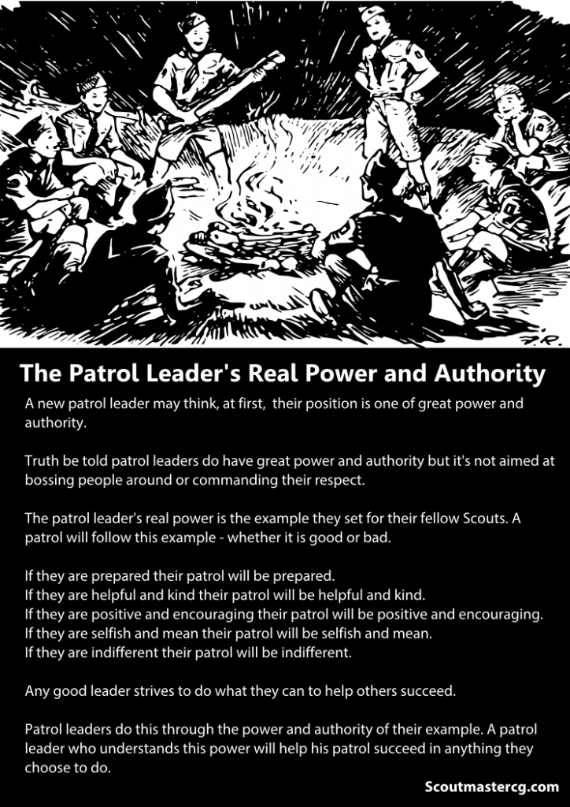

Troop 247 Parent Guide

**INTRODUCTION**

Welcome to the Boy Scouts of America! By becoming a parent of a Boy Scout, you are setting your son out on the grand adventure of Scouting. This is a tremendously important and rewarding endeavor that you will be able to share with him. What is it all about? What will be expected? What does it cost? We have prepared this booklet to answer these questions. The following pages describe the organization of a Troop and the advancement pattern that each boy will follow. Reading this will help you understand how your boy can progress through the ranks with your aide. It will help you understand how you can assist and what the various adult volunteers are doing to guide the Troop and your son. When is doubt, ask your son, if he doesn’t know the answer encourage him to find it for you.

**WHAT IS IT ALL ABOUT?**

There are three aims to scouting:

• To build character

• To foster citizenship

• To develop fitness

These three aims are the bedrock of the American Scouting movement. They represent the long term outcomes we want for every boy. It is the mission of the Boy Scouts of America to serve others by helping to instill values in young people, and in other ways to prepare them to make ethical choices over their lifetime in achieving their full potential. The values we strive to instill are based on those found in the Boy Scout Oath and Law.

These are the rules in Scouting, there are few more needed beyond these few words. Continued violation of these may lead to parents being requested to pick their child up from an activity or eventual dismissal from the Troop.

**SCOUT LAW**

*A Scout is:*

Trustworthy

Loyal

Helpful

Friendly

Courteous

Kind

Obedient

Cheerful

Thrifty

Brave

Clean

Reverent

**SCOUT OATH**

On my honor I will do my best

To do my duty to God and my country

and to obey the Scout Law;

To help other people at all times;

To keep myself physically strong,

mentally awake, and morally straight

Since 1910, these principles have been taught in an atmosphere of recreation and fun which allows young people to develop self-confidence, leadership and moral character. More and more men, trained as Scouts, are taking their places in today's world as responsible adult leaders. Men, who earned badges as Scouts, sit on the Supreme Court and in the chambers of Congress. Others hold important offices in our government, business and industry. Most of the members of congress were Scouts, as well as most of the astronauts who have walked on the moon.

The long list of famous scouts includes:

James Lovell Eagle Scout Commander of Apollo 13

Justice Anton Scalia Supreme Court Justice Eagle Scout

President John F. Kennedy Boy Scout

Neil A. Armstrong Eagle Scout First person to set foot on the Moon

President Gerald Ford Eagle Scout

Steven Spielberg Eagle Scout

J. Willard Marriott, Jr. Eagle Scout President of Marriott Corporation

William C. Devries, M.D. Eagle Scout Transplanted First Artificial Heart

Sam M. Walton Eagle Scout Chairman / CEO, Wal-Mart

Barber B. Conable, Jr. Eagle Scout President, World Bank

and many many more…..

The Boy Scouts of America is the largest youth oriented organization in the

United States. More than 4 million boys and leaders are currently registered in

the Boy Scouts of America.

Unlike Cub Scouting, which some of you are familiar with; Boy Scouting is a youth-lead organization. The boys learn how to organize and lead the Troop with supervision and mentoring from the adult leaders. The boys run the show. The boys in the Troop will be working towards their 1st class and then Eagle ranks. As they travel on their trail to Eagle they will not only learn how to lead a team to a goal, but they will actually lead teams of scouts in a number of situations. Many Eagle Scouts put their accomplishments on their resumes and find they are often considered in obtaining acceptance into college or the work force.

Boy Scouting also provides for growth of moral strength and character, teaches

Citizenship, and enhances the development of physical, mental and emotional fitness. This is all done in the spirit of fun and adventure.

Please take a few minutes to read Chapter 1 of your son's Boy Scout Handbook.

**For more information about our Troop visit our website and Facebook page**

**Troop247Reedsburg.Scoutlander.com**

**Facebook.com/Troop247ReedsburgWI**

**ORGANIZATION**

Troop 247 is a participating member of the Glacier’s Edge Council, Boy Scouts of America. The Troop's organization consists of a Chartered Organization, a Troop Committee, the Troop, and the Troop's Parents.

**Chartered Organization (Sponsor)**

Every Troop belongs to an organization. The Chartered Organization for Troop 247 is St Peter’s Church. The Chartered Organization shares our objectives for the boys and insures that there is adequate, trained leadership. The Charter Organization approves all Adult Members based on their membership requirements. We are considered a Youth Ministry branch of St Peter’s Lutheran Church and fall under the Elder Committee. A Chartered Organization Representative acts a liaison between us and the Church.

**Troop Committee**

The Troop Committee Functions as an administration and support organization for the Troop. The Troop Committee takes care of the non-program issues surrounding the Troop. For example: newsletters, Troop funds, fund raising activities, membership drives and Troop coordination, activity permits and coordination, advancement records, procurement and maintenance of Troop equipment. The Committee meets regularly during the Troop meeting the first Tuesday of the month. The meetings are informal but open to all parents and other interested adults. Every registered adult leader and parent is a voting member of the committee, but most decisions are made by the Scouts in their meetings. Rarely does our committee vote.

**Troop Meetings**

Troop 247 will hold meetings weekly. Meetings currently are held every Tuesday; from 6:30 p.m. to 7:30 p.m. Changes to the meeting schedule will be announced as early as possible to allow for proper planning. Troop 247 also has two Troop Swims during the first few months of the calendar year. Please check the Troop Calendar on our website.

**Adult Leadership**

Two registered adult leaders, or one adult leader and a Scout parent, one of which must be at least 21 years of age are required for all Troop 247 trips or outings.

**Patrols and Patrol Leaders**

The Troop is a group made up of patrols. Each Patrol usually consists of a Patrol Leader and no more than ten Scouts. The boys in a patrol elect their patrol leader who in turn appoints the assistant patrol leader. The Senior Patrol Leader is an elected position. The Senior Patrol Leader (SPL) selects his Assistant Senior Patrol Leader (ASPL). The Patrol Leaders, with the Senior Patrol Leader as their head, form the Patrol Leaders' Council (PLC), which plans the activities and runs the Troop meetings.

Elections for Patrol Leader and Senior Patrol Leader are held twice each year.

**Please attend Committee Meetings when you can. Parental involvement is crucial to a healthy Boy Scout Troop.**

**ScoutParent**

The role of parents within Troop 247 is to be supportive of the Troop's efforts and to provide the atmosphere Scouts need to learn and excel. Parents should try to:

1. Read their Scout's handbook and understand the purpose and methods of Scouting.

2. Actively follow their Scout's progress (or lack thereof) and offer encouragement and a push when needed.

3. Show support to both the individual Scout and the Troop by attending all Troop Courts of Honor even if your son is not receiving an award.

4. Assist, as requested, in all Troop fund-raisers and other such activities. All such assistance lowers the cost of the program we offer to the Scouts and, therefore, lowers each family's cash outlay for their Scout(s).

5. Be aware of the Troop program and annual calendar.

6. Consider becoming a Volunteer Leader or serve actively on the Troop Committee. As a parent of a Scout you are automatically part of the Troop Committee.

7. Attend a camp out with your son from time to time.

8. Like our Facebook page and share posts to spread to your friends what we do

9. Talk to your friends and families with Scout aged boys to promote the program ask them to consider attending a meeting or camp out.

10. Follow the non-bullying agreement included in this parent guide.

11. Understand that Scouts and Leaders are volunteers and are not perfect and make mistakes. Our leaders volunteer countless hours to support our Scouts. Please keep this in mind.

Contact our ScoutParent Coordinator if you have any further questions.

**A word about parents attending a camp out. Camp is like a sport. A campout is the field of Scouting where they play the game, Scout meetings are the practice where they plan and practice for the game. Adults should stay off the field as much as possible. If you attend camp with your son, at camp he is not your son. His care belongs to that of his Patrol Leader, Senior Patrol Leader, and Scoutmaster. If he comes to you with a need or a question you need to refer him to his Patrol Leader. Please do not help pack his gear, set up his tent, cook his food, or any other task you feel he needs help with. Do not do anything for the Scout that he can do for himself. This will be and is hard! Encourage other adults to do the same. Special treatment of Scouts by their attending parents will not be tolerated. This breaks apart the cohesion of the group and breaks down all work to create and foster Citizenship in the Patrol which is an aim in Scouting. The Scouts may not do the task the way you may do it or may fail over and over but please stay off the field and enjoy the game from a comfy chair. Every failure leads to learning.**

The next page shows the positions that are available in a Scout Troop. None of these positions are to be taken lightly. If your son is elected or appointed to a youth leadership position it is a high honor and with it comes a lot of responsibility. The most important job of a Youth Leader is to Lead, Train, and Inspire Scouts to First Class Rank. All other duties are secondary but also important.

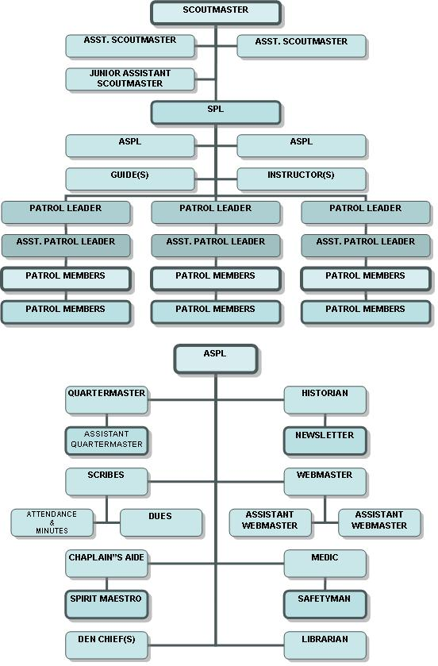

Above is the Troop Organization Chart… for information it is best to follow this chart from the BOTTOM up. If you have a question ask your son, if not answered he should ask his APL, if needed then ask his PL, if needed ask the ASPL (Assistant Senior Patrol Leader) and so on forth. If the chain of command is not followed you may be guided to ask your Patrol Leader or Senior Patrol Leader. This allows for leadership to belong to the boys, where it is supposed to be in Boy Scouts.

**The Scoutmaster is in charge of maintaining the Scouting Program and to assist the Senior Patrol Leader. The Committee works to support the Program FOR the Scouts.**

**YOUTH PROTECTION**

**Mandatory Reporting of Child Abuse**

All persons involved in Scouting shall report to local authorities any good faith suspicion or belief that any child is or has been physically or sexually abused, physically or emotionally neglected, exposed to any form of violence or threat, exposed to any form of sexual exploitation including the possession, manufacture, or distribution of child pornography, online solicitation, enticement, or showing of obscene material. No person may abdicate this reporting responsibility to any other person.

Leaders also notify the Scout executive of this report, or of any violation of BSA’s Youth Protection policies, so that he or she may take appropriate action for the safety of our Scouts, make appropriate notifications, and follow-up with investigating agencies.

**How does the BSA help prevent child abuse in Scouting?**

The Boy Scouts of America has adopted a number of policies aimed at eliminating opportunities for abuse within the Scouting program. These policies focus on leadership selection and on placing even greater barriers to abuse than already exist today in Scouting.

New leaders are required to take Youth Protection training before submitting an application for registration.

All Parents of Troop 247 must take Youth Protection prior to attending an overnight camp out.

The BSA’s Youth Protection training has been in existence long enough for it to be understood and accepted as a mandated training for **ALL** registered and new BSA adult volunteers.

Youth Protection training must be taken every two years. If a volunteer’s Youth Protection training record is not current at the time of re-charter, the volunteer will not be reregistered.

**Leadership Selection**

The Boy Scouts of America takes great pride in the quality of its adult leadership. Being a leader in the BSA is a privilege, not a right. The quality of the program and the safety of youth members demands high-quality adult leaders. We work closely with chartered organizations to help recruit the best possible leaders for their units.

The adult application requests background information that is checked by the unit committee or the chartered organization before accepting an applicant for unit leadership. While no current screening techniques exist that can identify every potential child abuser, we can help reduce the risk of accepting a child abuser by learning all we can about an applicant for a leadership position—including his or her experience working with children and why he or she wants to be a Scout leader.

Youth safety is of paramount importance to the Boy Scouts of America. It is important to implement this training at all levels of the organization. BSA continually seeks to increase awareness of this societal problem and to create even greater barriers to abuse than already exist today in Scouting to provide the most secure environment possible for its youth members. A social security number is required for every Adult Leader and Merit Badge Councilors. This is a National Council Requirement.

**Scouting's Barrier to Abuse**

The BSA has adopted the following policies for the safety and well-being of its members. These policies are primarily for the protection of its youth members; however, they also serve to protect adult leaders.

**Two-deep leadership on all outings required.** Two registered adult leaders, or one registered leader and a parent of a participating Scout or other adult, one of whom must be 21 years of age or older, are required for all trips and outings. There are a few instances, such as patrol activities, when the presence of adult leaders is not required and adult leadership may be limited to training and guidance of the patrol leadership. With the proper training, guidance, and approval by the troop leaders, the patrol can conduct day hikes and service projects. Appropriate adult leadership must be present for all overnight Scouting activities; coed overnight activities—even those including parent and child—require male and female adult leaders, both of whom must be 21 years of age or older, and one of whom must be a registered member of the BSA. The chartered organization is responsible for ensuring that sufficient leadership is provided for all activities.

**One-on-one contact between adults and Scouts prohibited.** One-on-one contact between adults and youth members is not permitted. In situations that require personal conferences, such as a Scoutmaster’s conference, the meeting is to be conducted in view of other adults and youths. The only exceptions are parents and their child and human safety concerns.

**Separate accommodations for adults and Scouts required.** When camping, no youth is permitted to sleep in the tent of an adult other than his or her own parent or guardian. Councils are strongly encouraged to have separate shower and latrine facilities for females. When separate facilities are not available, separate times for male and female use should be scheduled and posted for showers. Likewise, youth and adults must shower and change clothing at different times.

**Privacy of youth respected.** Adult leaders must respect the privacy of youth members in situations such as changing clothes and taking showers at camp, and intrude only to the extent that health and safety require. Adults must protect their own privacy in similar situations.

**Inappropriate use of cameras, imaging, or digital devices prohibited.** While most campers and leaders use cameras and other imaging devices responsibly, it has become very easy to invade the privacy of individuals. It is inappropriate to use any device capable of recording or transmitting visual images in shower houses, restrooms, or other areas where privacy is expected by participants.

**No secret organizations.** The Boy Scouts of America does not recognize any secret organizations as part of its program. All aspects of the Scouting program are open to observation by parents and leaders. This does include the Order of the Arrow.

**No hazing.** Physical hazing and initiations are prohibited and may not be included as part of any Scouting activity.

**No bullying.** Verbal, physical, and cyber bullying are prohibited in Scouting. All parents must sign our non-bullying agreement before allowed to camp with Scouts.

**Youth leadership is monitored by adult leaders.** Adult leaders must monitor and guide the leadership techniques used by youth leaders and ensure that BSA policies are followed.

**Discipline must be constructive.** Discipline used in Scouting should be constructive and reflect Scouting’s values. Corporal punishment is never permitted.

**Appropriate attire is required for all activities.** Proper clothing for activities is required. For example, skinny-dipping or revealing bathing suits are not appropriate in Scouting.

**Members are responsible for acting in accordance with the Scout Oath and Scout Law.** All members of the Boy Scouts of America are expected to conduct themselves in accordance with the principles set forth in the Scout Oath and Scout Law. Physical violence, theft, verbal insults, drugs, and alcohol have no place in the Scouting program and may result in the revocation of a Scout’s membership.

**Units are responsible for enforcing Youth Protection policies.** The head of the chartered organization or chartered organization representative and the local council must approve the registration of the unit’s adult leader. Adult leaders of Scout units are responsible for monitoring the behavior of youth members and interceding when necessary. Parents of youth members who misbehave should be informed and asked for assistance as soon as possible. Any violations or concerns of the BSA’s Youth Protection policies must immediately be reported to the Leader in Charge who will contact the Scout executive as well as the local authorities.

**CONTROLLED SUBSTANCES**

## Alcohol

It is the policy of the Boy Scouts of America that the use of alcoholic beverages and controlled substances is not permitted at encampments or activities on property owned and/or operated by the Boy Scouts of America, or at any activity involving participation of youth members.

## Tobacco

Adult leaders should support the attitude that they, as well as youths, are better off without tobacco in any form and may not allow the use of tobacco products at any BSA activity involving youth participants. All Scouting functions, meetings, and activities should be conducted on a smoke-free basis, with smoking areas located away from all participants.

## Drugs

The misuse of drugs happens in all levels of our society. We may be confronted with the problem at any time; therefore, we need to understand the misuse of drugs and what can be done about the situation. See the Drug Enforcement Administration website (http://www.justice.gov/dea/index.htm) for detailed information on controlled substances and their effects.

## Medical Marijuana

It is unacceptable for anyone to use or be under the influence of medical marijuana at or during any Scouting activity.

**ADVANCEMENT**

There are many definitions of advancement, but the Scouting definition might well be, simply, "the art of meeting a challenge." For that is exactly what the Boy Scout advancement program asks the boys to do. The Boy Scout advancement program provides a ladder of skills that a Scout climbs at his own pace. As he acquires these skills he moves up through a series of ranks, for which he is awarded badges; Tenderfoot, Second Class, First Class, Star, Life, and Eagle. The higher he climbs the more challenging his tasks -- and the more rewarding.

Achievements include:

• Learning skills that qualify for Scouting's more rugged and exciting outdoor challenges.

• Developing body and mind, growing self-confidence, and helping younger Scouts climb the advancement ladder.

• Discovering how it feels to go further -- in so many ways -- than he ever though he could.

We don't look at advancement as a goal, but as a natural outcome of a planned, quality Troop program.

There are four steps of advancement:

• The Boy Scout **Learns**

• The Boy Scout is **Tested**.

• The Boy Scout is **Reviewed**.

• The Boy Scout is **Recognized**.

**Advancement through First Class**

From the time the Scout enters the Troop through the time he earns advancement to First Class, he is learning basic scouting skills to enable him to camp, hike, swim, cook, tie knots, administer first aid, and perform other tasks in the outdoors and to work as a member of a team. With those first steps the scout begins to build themselves physically, mentally, and morally. He will start to live with the Scout Oath and Law. Soon he will learn the symbolism inherent in the Scout badge; he will learn that there are three points of the trefoil which stand for the three parts of the Scout Oath:

- Duty to God and country, duty to other people, and duty to yourself.

The goal of National Council is for the Scout to achieve the rank of First Class within his

first year in the Troop. This is a sign that the scout has mastered the fundamentals of scouting and can begin to start the long process of learning to lead others, refining the learned skills and learning additional skills.

**Advancement from First Class to Eagle**

From the achievement of First Class through Eagle, the Scout will be demonstrating leadership, performing service projects, earning merit badges and using the skills learned while achieving the rank of First Class. The next ranks he will earn are Star and Life. These ranks are harder to obtain than the earlier ranks, but are also more interesting for the older scouts. Upon completion of all the requirements for Star and

Life the Scout will be eligible to work for Eagle. The original principals, the Scout Oath and Law now have fuller meaning for the Scout and their understanding of them is much greater. The final steps towards Eagle are filled with leadership experiences. Details for advancement are contained in the Boy Scout Handbook, which every Scout should obtain as soon as possible after joining the Troop. Take a look at Chapter 1. This short chapter has an advancement summary through First Class.

**Merit Badges**

The goal of the merit badge program is to expand a Scout's areas of interest and to encourage the Scout to meet and work with adults in a chosen subject. Merit badges are earned by a Scout working with a registered merit badge counselor. The Council chooses people to council Merit Badges with knowledge or experience in a given subject as recommended by Troops. This gives the Scouts a chance to speak to someone in a field they may find interesting. You may be qualified to instruct several of the 130 merit badges available to Scouts. If interested contact your Scoutmaster.

Many adults today have found their careers while earning a particular Merit Badge. The Scout is required to contact the counselor to arrange for times and places to meet with the counselor. When the Scout completes the work on the merit badge the counselor will inform the Scoutmaster that the Scout has completed the requirements for that badge. Merit Badges earned will be presented to the Scout as soon as possible and he will be recognized during the Troop's Court of Honor.

**Boards of review**

When a Scout has completed all the requirements for a rank, he appears before a board of review composed of members of the Troop committee. The purpose of the review is not an examination. Rather it is to determine the Scout's attitude and acceptance of Scouting's ideals; to ensure that the requirements have been met for advancement, to discuss the Scout's experiences in the Troop and the Troop's program, and to encourage him to keep working towards advancement. A Board of Review may also be held to counsel a boy about his lack of progress toward advancement or just to get a feel for how the program is running.

**Courts of Honor**

Troop 247 will conduct a Court of Honor regularly. The Court of Honor recognizes all Scout appointments, elections, awards, and advancements since the last Court of Honor. Adult recognition may be presented prior to the opening of the Troop Court of Honor or after its conclusion. It is the responsibility of the Troop's Patrol Leaders' Council to plan and conduct the Troop Courts of Honor. The Troop Committee will support the Courts of Honor as requested. The Court of Honor is a public ceremony, and is a chance for the Scouts to be publicly recognized for their achievements. Parents and all other interested individuals are encouraged to attend. Often a pot luck style meal is held for members, parents, and leaders to promote discussion, interaction, and enjoy fellowship with one another.

**ADMINISTRATIVE**

**Rechartering and Fees**

Recharting is the annual collection of registration for the Scouts and Leaders as well as a formal visit to the chartering organization to renew their commitment for the coming year. Rechartering the Troop must be completed by December of each calendar year.

**Annual Registration Fees**

How much does Boy Scouting cost? As little as possible, but nothing worthwhile is free. The annual fee for each Scout in Troop 247 is: $29.00

• $24.00 for national BSA membership (required)

• $4.00 insurance (required)

• $12.00 for Boys Life magazine (optional but highly recommended)

• $24.00 for Adult Leaders

**Fees for Outings** *I* **Activities**

Individual activities may have fees associated with them. If so, the parents will be notified. Generally, Ground fees are $5 plus whatever each patrol spends on food for the weekend. We like to keep the camping weekend total to about $20 or less a person. To keep costs down for the Scouts, leaders and parents attending are expected to pay the same fees. However District and Council events have an entry fee as well.

**Fundraising**

Additional funds are raised by the boys through fundraising projects throughout the year. A portion of the proceeds from your son’s fundraising will be applied to his personal Scout Account managed and owned by the Troop to be used on fees, limited equipment, or select Scouting needs. Upon leaving the Troop or unannounced absence of 90 days Scouts have 90 days to use fees in the account for Scout purposes or the funds will be transferred to the Troop General Fund upon Troop Committee recommendation. When a boy turns 18 and continues as an Adult Leader his Scout Account will stay current until it reaches zero or after an unannounced absence of 90 days. After 90 days the balance of any Scout or Scouter account transfers into the Troop general fund. Scout Account Funds Cannot be transferred to another unit per IRS requirements, the funds are property of the Unit and Chartered Organization.

**UNIFORM**

The Scout uniform helps to achieve the objectives of Scouting. The uniform by itself cannot make a good Scout or a good Troop, but its use has been proven to improve both the Scout and the Troop because it is a visible symbol of Scouting and unity. Each scout is required to have and wear, within a reasonable amount of time after joining the Troop, the following uniform items:

Field or “Class A” Uniform

• Tan scout shirt with appropriate insignia and patches (Glacier’s Edge Council Strip, olive shoulder loops, and patrol emblem.)

• Troop number

• Olive Scout pants or shorts (Official Field Pants Preferred)

• Boy Scout Socks, for wearing with shorts

• Boy Scout Hat

• Scout web belt and buckle or any other Scout Belt

• Sensible shoes or hiking boots. Socks are required

• A neckerchief. Our neckerchief color is orange they are available through the Troop.

• A “slide” or Woggle to hold the neckerchief in place.

Activity or "Class B" Uniform (worn, as instructed by Troop leadership, when

activities may cause damage to the field uniform).

• Scout Appropriate T-shirt

• Scout pants or shorts.

• Boy Scout Socks, for wearing with shorts.

• Sensible Shoes or hiking boots. Socks are required.

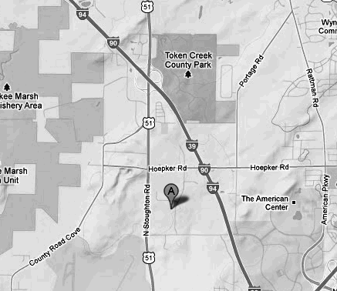

Uniforms and insignia are worn a certain way. The Troop Leaders and staff at the

Scout Shops will be able to answer any questions you might have on where to put what badge. Inside covers of the Handbook there are guides for badge placement.

**SCOUT SHOPS**

There two Scout Shops in Glacier’s Edge Council where you can purchase scout uniforms and supplies:

**National Scout Shop**

5846 Manufacturers Drive  
Madison, WI 53704-6278

Monday – Friday 9:00 am to 6:00 pm;

Madison Scout Shop

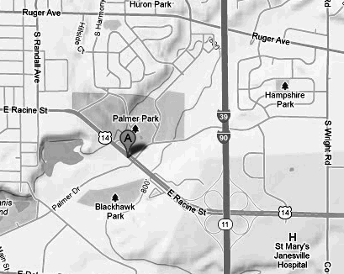Saturday 9:30 am – 1:00 pm  
(608) 273-1005  
(800) 213-1418  
FAX (608) 273-8686

**Janesville Scout Service Center**

2300 East Racine Street  
Janesville, WI 53545-4340  
Monday – Thursday 11:00am-6:00pm

Friday: 11:00am – 5:00pm  
(608)314-3193

FAX (608) 756-4676

Or Visit Scoutstuff.org for the online Scout Shop

Leaders visit the Madison Office frequently, if you need an item, let them know and they can pick it up for you.

Janesville Scout Shop

Most important of all have fun… Scouting is a game, a game with a purpose! –B.P.

District Executive – Clarence Renfroe 608-772-8939

Clarence.Renfroe@scouting.org

Prices Subject to change and are based off of 2012 prices here

Scout Gear Suggestions

Scout Gear should be simplistic in nature. The more complicated an item, the more your son will play with that item when he really shouldn’t or more likely the more likely that part of the component will fail. Troop 247 and its leaders are not responsible for any damage or loss of personal items. Please keep this in mind when bringing expensive cameras and other equipment. I recommend waterproof containers for any electronic device brought to Scout Events.

Discounts

Your son’s Scout Membership card entitles him to discounts at the following merchants.

Gander Mountain 10% on Scout Camping gear

Fontana Sports 10% (Eagle Scout Owned)

Erehwon 10%

Campmor 20% when purchased by the Troop with a Troop Check

Colman Outlet Store 10%

Scoutstuff.org and our local Scout Shop often has sales on certain camp items!

When in doubt ask if they offer discounts to Boy Scouts (usually need to present card as proof of membership)

What are the 10 Essentials? Almost every Scoutmaster tells the scouts to remember the 10 Essentials for the next camp-out.   
  
Here’s what BSA recommends for the Scout Basic Essentials  
  
_ Pocketknife   
_ First aid kit   
_ Extra clothing   
_ Rain gear   
_ Water bottle   
_ Flashlight   
_ Trail food (Small amount for emergency use only) (NO FOOD IN TENTS)  
_ Matches and fire starters   
_ Sun protection (remember your hat and sunglasses as well as sunscreen)   
_ Map and compass   
  
For most campouts you’ll need a few more items (a more complete list is found on our Troop Website!)  
_ A loud whistle, for emergencies only   
_ Clothing and shoes appropriate for the season and activity   
_ Sleeping gear (sleeping bag, pad, tarp)   
_ Mess kit (fork, spoon, knife, bowl, plate, cup)   
_ Toiletry Kit (soap, toothbrush, toothpaste, dental floss, comb, towel, bug spray - seasonally)   
_ Backpack or duffel bag   
_ Scout Handbook   
_ Merit badge books and cards   
_ Optional (swimsuit, book, notebook and pen, camera, fishing gear)

Boy Scout Troop 247

St. Peter’s Lutheran Church, Reedsburg, WI

Adult Code of Conduct

Printed Name: .

Date:

Statement of Understanding

The Troop Committee has established this Code of Conduct to provide Scout Parents/Scouter of Troop 247 with a framework of expectations for adults. This Code of Conduct will help ensure a common language and understanding of behavioral expectations, and consequences, allowing us to create an atmosphere conducive to fun, safety, and the values of Scouting.

Code of Conduct –

I agree to abide by this Code of Conduct, as follows:

1. I will conduct myself in accordance with the principles of the Scout Oath and Law.

2. I will not engage in behavior that constitutes discrimination or harassment in any way to any Scout, Scout Parent/Scouter or leader.

3. I will not use social media as a method of Scout, Scout Parent or Troop “bashing”.

4. I will seek to immediately resolve any issue that may present itself by discussing it with the Scoutmaster, or Committee Chair.

5. I will not engage in gossip about any Scout, Scout Parent or the Troop.

6. While participating in Scouting activities, I will obey the safety rules and instructions of all supervisors and use positive reinforcement and communication.

7. I understand and acknowledge that, if my behavior or choices are not in keeping with this Code of Conduct;

1. I will be asked by the Scoutmaster (or other Scouter in charge) to leave the Scouting activity and I will do so without incident and without refund of any fees paid, if applicable.
2. My behavior may result in other disciplinary action (up to and including suspension from

participation or expulsion from the Troop). If a Scout Parent/Scouter’s membership in the Troop is revoked, the Troop Committee will promptly notify Council of the action.

1. The Troop Committee (or its designee) will review my behavior and take what it determines, in its sole discretion and authority, to be appropriate disciplinary action, which determination will be final and binding.
2. This Code of Conduct is the policy of the Troop Committee, and I may be subject to additional disciplinary action by our Glacier’s Edge Council.

By signing this Code of Conduct, I promise on my honor as a Scout Parent/Scouter that I will do my best to live up to the Scout Oath and Law and follow this Code of Conduct. If I desire to report a violation of this Adult Code of Conduct, I will report it to the Scoutmaster, or Committee Chairman.

Signed: Date:

Witness: Date:

Troop 247 Adult Code of Conduct.0215

Notes Updated January 2016

Any further questions ask your Scout…Patrol Leader…Senior Patrol Leader….you get the idea!

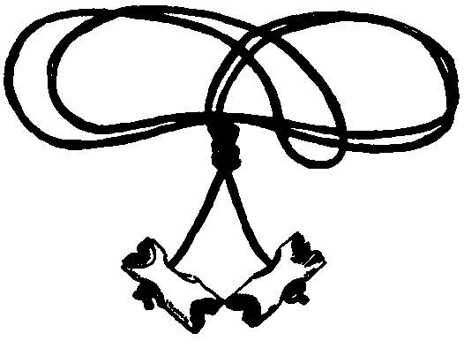

Created for C3-620-12